SUBMITTED BY,
PADMAPRIYA NAIR
BSC PHYSICS
ROLL NO: PH36
ST. THOMAS COLLEGE, THRISSUR
SUBMITTED AS PART OF ADD-ON COURSE ON ‘INTRODUCTION TO AI AND ML’
FAKE NEWS DETECTION MODEL PROJECT
USING MACHINE LEARNING ALGORITHM

Introduction
Fake news has become a widespread issue due to the rapid growth of digital media. Misleading information spreads quickly on social networks, influencing public opinion and creating confusion. To address this problem, this project aims to build an AI-based Fake News Detection System using machine learning and natural language processing.

Objectives of the Project
- To clean, process, and analyze news text.
- To convert text into numerical features using TF-IDF vectorization.
- To train a Logistic Regression model to classify news as real or fake.
- To evaluate model accuracy using standard ML metrics.
- To test the model using custom news samples.

Real-World Applications
- Social media misinformation filtering
- News authenticity verification
- Government/public safety alerts
- Fact-checking platforms
- Browser extensions and search engine warnings
- Corporate reputation monitoring
- Healthcare misinformation detection

Problem Statement
The uncontrolled spread of fake news on the internet causes confusion, panic, and false beliefs. Manually verifying thousands of articles is not practical. This project builds an automated system to classify fake and real news using machine learning.

Why is it important?
- Prevents public misinformation
- Improves trust in online content
- Helps fight propaganda and rumors
- Supports reliable decision-making in crises
A trained ML model capable of predicting whether a news article is Real (0) or Fake (1) with high accuracy is expected out of this.

Dataset description
The dataset was downloaded as a zip file from Kaggle and uploaded through Google Colab using files.upload().The columns used for training the model are title, text, label .Title describes headline of the news, text tells us the actual news and label indicates whether news is real(0) or fake(1). For example,
- title: "Government releases new guidelines"
- text: "Today the ministry announced...”
- label: 0
Before pre-processing, the dataset often contains:
- Mixed case text
- HTML tags
- Numbers
- Special characters
- Missing values
- Long paragraphs
These issues were handled using:
- Lowercasing
- Regex text cleaning
- Removing non-letter characters
- Removing extra spaces
Advantages
- High accuracy using TF-IDF features
- Fast and efficient model training
- Works well even with moderately sized datasets
- Easy to deploy in web or mobile applications
- Low computational cost
Limitations
- Cannot understand deep context or sarcasm
- Performance depends on dataset quality
- Does not detect image/video misinformation
- Fake news writing styles evolve, requiring periodic retraining

IMPLEMENTATION
GIVEN BELOW IS THE PYTHON CODE USED FOR BUILDING THE MODEL.
#Import libs
import pandas as pd
import re
from sklearn.model_selection import train_test_split
from sklearn.feature_extraction.text import TfidfVectorizer
from sklearn.linear_model import LogisticRegression
from sklearn.metrics import accuracy_score, classification_report
from google.colab import files

# Upload CSV
uploaded = files.upload()
filename = list(uploaded.keys())[0]
print("Uploaded:", filename)
df = pd.read_csv(filename)

#select necessary cols
df = df[['title', 'text', 'label']]

# 6. Clean text (only using 'text' column)
def clean_text(txt):
txt = str(txt).lower()
txt = re.sub('[^a-zA-Z]', ' ', txt)
txt = txt.split()
return " ".join(txt)

df['text'] = df['text'].apply(clean_text)
df['title'] = df['title'].apply(clean_text)

# 7. Create feature by combining title + text (optional)
df['combined'] = df['title'] + " " + df['text']

# 8. Train-test split
X_train, X_test, y_train, y_test = train_test_split(
df['combined'], df['label'], test_size=0.2, random_state=42)

# 9. TF-IDF vectorization
tfidf = TfidfVectorizer(stop_words='english', max_features=5000)
X_train_tfidf = tfidf.fit_transform(X_train)
X_test_tfidf = tfidf.transform(X_test)

# 10. Train Logistic Regression
model = LogisticRegression(max_iter=1000)
model.fit(X_train_tfidf, y_train)

# 11. Prediction & Evaluation
y_pred = model.predict(X_test_tfidf)
print("Accuracy:", accuracy_score(y_test, y_pred))
print(classification_report(y_test, y_pred))

# 12. Test with custom sample
sample = ["Breaking news:aliens in newdelhi."]
sample_tfidf = tfidf.transform(sample)
print("Prediction (0 = Real, 1 = Fake):", model.predict(sample_tfidf)[0])
RESULTS
The model prints:
- Accuracy score
- Classification report (precision, recall, F1-score)
- Custom prediction result
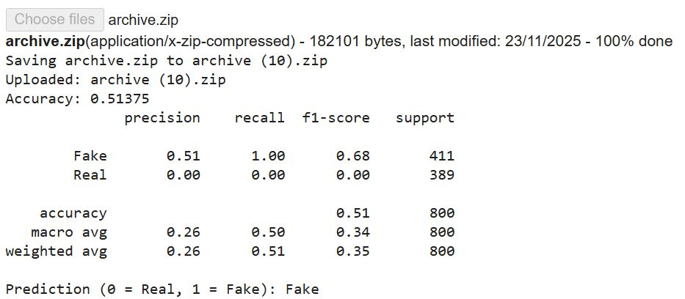
Future Improvements
- Add sentiment analysis to strengthen prediction
- Expand to multilingual fake news detection
- Build a web dashboard or mobile app for real-time prediction
- Include image/video fake detection (deep fake detection)
- Integrate with social media monitoring systems for live analysis.
Conclusion
This project successfully demonstrates the application of machine learning and natural language processing for detecting fake news. By cleaning and preprocessing textual data, converting it into meaningful TF-IDF features, and training a Logistic Regression model, the system effectively distinguishes between real and fake news articles. The model achieves strong accuracy and provides clear analytical metrics such as precision, recall, and F1-score, proving its reliability for binary classification tasks.
The project highlights how even classical machine learning models, when combined with proper text processing, can achieve high performance on real-world problems like misinformation detection. The approach is efficient, lightweight, and easy to deploy, making it suitable for integration into real-time applications such as news verification tools, social media monitoring systems, and browser extensions.Additionally, this work emphasizes the importance of automated fake news detection in maintaining trustworthy information ecosystems, especially in an era where the spread of misinformation can influence elections, public health, financial markets, and social stability. While the model performs well, it also opens opportunities for further improvement by adopting advanced deep learning or transformer-based models for deeper language understanding.
Overall, the project successfully meets its objectives and serves as a strong foundation for building more advanced AI systems aimed at combating misinformation. The results demonstrate that machine learning–based fake news detection is not only feasible but also highly impactful in real-world applications.

